

SRI KRISHNA COLLEGE OF ENGINEERING AND

TECHNOLOGY

COIMBATORE – 641008.

(AN AUTONOMOUS INSTITUTION)
(ACCREDITED BY NAAC WITH ‘A’ GRADE | AFFILIATED TO ANNA UNIVERSITY)

DEPARTMENT OF SCIENCE AND HUMANITIES

21MA302 – MATHEMATICAL STRUCTURES LABORATORY

RECORD BOOK

ACADEMIC YEAR 2022 - 2023

SUBMITTED BY

Name : RASIKA B

Register No : 727721EUIT126

Department / Section : INFORMATION TECHNOLOGY / C

Year / Semester : II / III

NOV/DEC 2022

SRI KRISHNA COLLEGE OF ENGINEERING AND

TECHNOLOGY

COIMBATORE – 641008.

(AN AUTONOMOUS INSTITUTION)
(ACCREDITED BY NAAC WITH ‘A’ GRADE | AFFILIATED TO ANNA UNIVERSITY)

DEPARTMENT OF SCIENCE AND HUMANITIES

21MA302 – MATHEMATICAL STRUCTURES LABORATORY

RECORD BOOK

PRACTICAL RECORD

Name : RASIKA B

Register No : 727721EUIT126

Department / Section : INFORMATION TECHNOLOGY / C

Year / Semester : II / III

BONAFIDE CERTIFICATE

Certified bonafide record work done by Mr./Ms.__________ RASIKA B_______________________, Reg.No.___ 727721EUIT126__________________ during the academic year 2022-2023.

STAFF INCHARGE

Submitted for Anna university practical examination, held on _________________.

Index

S.No | Date | Name of the experiment | Marks | Staff Sign
1 | 18.8.22 | Generate The Truth Table For Mathematical Logic Using Suitable Mathematical Software.
2 | 18.8.22 | Assign the truth table actions to decisions using suitable mathematical software.
3 | 24.8.22 | Examine the logical validity of arguments using suitable mathematical software.
4 | 24.8.22 | Testing the truth values of the statements by logical operators using MATLAB.
5 | 26.8.22 | Verification of De-Morgan’s Law using MATLAB.
6 | 26.8.22 | Set operations using MATLAB.
7 | 26.8.22 | Compute permutations functions using suitable mathematical software.
8 | 26.8.22 | Compute combinations functions using suitable mathematical software.
9 | 5.9.22 | Compute Prime numbers using MATLAB.
10 | 5.9.22 | Compute least common multiple of two integers using suitable mathematical software.
11 | 5.9.22 | Compute greatest common divisor of two integers using suitable mathematical software.
12 | 5.9.22 | Compute Quotient and remainder of two integers by division algorithm using suitable mathematical software.

Faculty In-charge

Department of Science and Humanities

21MA302 MATHEMATICAL STRUCTURES

EX.NO:1 | Generate The Truth Table For Mathematical Logic Using Suitable  Mathematical Software.
DATE:18.8.22

OBJECTIVE:
To generate the truth table for mathematical logic using mathematica.
SOFTWARE REQUIRED:
Execute Wolframcloud notebook (https://www.wolframcloud.com)
QUESTION 1:
Write a program to display all the possible output of Boolean expression p or q
CODING
BooleanTable[p || q, {p, q}]
OUTPUT
{True, True, True, False}

QUESTION 2:
Write a program to create the truth values of the Boolean expression 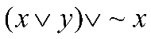
CODING
f = (x||y)||!x;
BooleanTable[{x,y }-> f, {x,y}]

OUTPUT

{{True,True}->True,{True,False}->True,{False,True}->True,{False,False}->True}
>>Tableform

True True
True

True True
False

False True
True

False True
False

QUESTION 3:
Using Call to the Truth table function, create the truth table for the operator CONJUCTION.
To set up function:
TruthTable[op_, n_] := Module[ { l = Flatten[Outer[List, Sequence @@ Table[{True, False}, {n}]], n - 1], a = Array[A, n] }, DisplayForm[ GridBox[Prepend[Append[#, op @@ #]& /@ l, Append[a, op @@ a]], RowLines -> True, ColumnLines -> True] ] ]
CODING
TruthTable[And[#1, #2] &, 2]
OUTPUT
A[1] | A[2] | A[1]&&A[2]
True | False | False
True | False | False
False | True | False
False | False | False

QUESTION 4:
Using Call to the Truth table function, create the truth table for the Boolean expression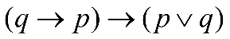.
To set up function:
TruthTable[op_, n_] := Module[ { l = Flatten[Outer[List, Sequence @@ Table[{True, False}, {n}]], n - 1], a = Array[A, n] }, DisplayForm[ GridBox[Prepend[Append[#, op @@ #]& /@ l, Append[a, op @@ a]], RowLines -> True, ColumnLines -> True] ] ]
A[1]=p;
A[2]=q;

CODING
TruthTable[Implies[Implies[#2, #1],Or[#1, #2] ]&, 2]
OUTPUT
p | q | 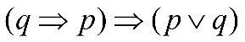
True | False | True
True | False | True
False | True | True
False | False | False

Problems for Practice
- Write a program to display all the possible output of Boolean expression NOT P

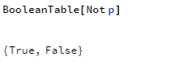
- Write a program to display all the possible output of Boolean expression 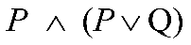

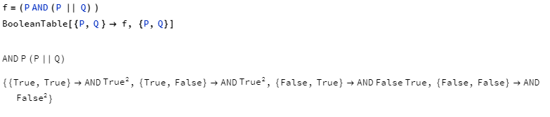

- Write a program to create the truth values of the Boolean expression 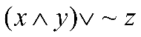

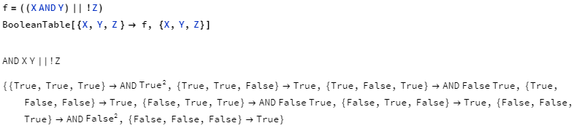

- Write a program to create the truth values of the Boolean expression 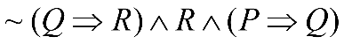

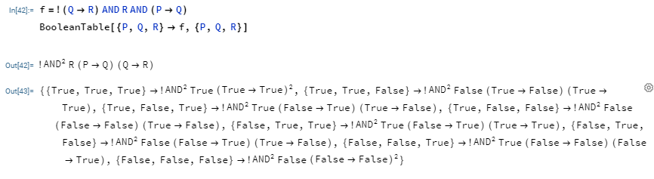

- Write a program to create the truth values of the Boolean expression 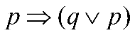

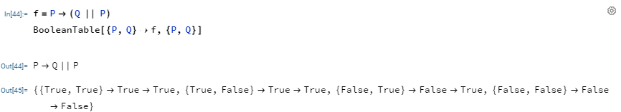

Conclusion :
Mathematica represents Boolean expressions in symbolic form, so they can not only be evaluated, but also be symbolically manipulated and transformed. Incorporating state-of-the-art quantifier elimination, satisfiability, and equational logic theorem proving, the Mathematica provides a powerful framework for investigations based on Boolean algebra.

EX.NO:2 | Assign the truth table actions to decisions using suitable mathematical software
DATE: 18.8.22

OBJECTIVE:
To make decisions on the validity of logical statement by assigning the truth table for using mathematica.
SOFTWARE REQUIRED:
Execute Wolframcloud notebook (https://www.wolframcloud.com)
QUESTION 1:
Write a program to check whether the statements (p v q) and (q v p) are equivalent.
To set up function:
TruthTable[op_, n_] := Module[ { l = Flatten[Outer[List, Sequence @@ Table[{True, False}, {n}]], n - 1], a = Array[A, n] }, DisplayForm[ GridBox[Prepend[Append[#, op @@ #]& /@ l, Append[a, op @@ a]], RowLines -> True, ColumnLines -> True] ] ]
A[1]=p;
A[2]=q;

CODING

TruthTable[Equivalent[Or[#1, #2], Or[#2, #1]] &, 2]
Print["Since all the Truth values are true, the given statements are equivalent"]

OUTPUT
p | q | 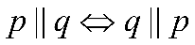
True | False | True
True | False | True
False | True | True
False | False | True
Since all the Truth values are true, the given statements are equivalent
QUESTION 2:
Generate the truth table to portray the validity of Complement Law.
To set up function:
TruthTable[op_, n_] := Module[ { l = Flatten[Outer[List, Sequence @@ Table[{True, False}, {n}]], n - 1], a = Array[A, n] }, DisplayForm[ GridBox[Prepend[Append[#, op @@ #]& /@ l, Append[a, op @@ a]], RowLines -> True, ColumnLines -> True] ] ]
A[1]=p;

CODING

TruthTable[Equivalent[Or[#1, Not[#1]],True] &, 1]
TruthTable[Equivalent[#1&& Not[#1],False] &, 1]
Print["Since all the Truth values are true, Complement Law is valid"]

OUTPUT
p | 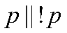
True | True
False | True
p | 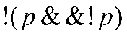
True | True
False | True
Since all the Truth values are true, Complement Law is valid.
QUESTION 3:
Generate the truth table to portray the validity of Distributive Law.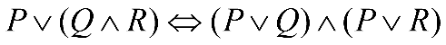.
To set up function:
TruthTable[op_, n_] := Module[ { l = Flatten[Outer[List, Sequence @@ Table[{True, False}, {n}]], n - 1], a = Array[A, n] }, DisplayForm[ GridBox[Prepend[Append[#, op @@ #]& /@ l, Append[a, op @@ a]], RowLines -> True, ColumnLines -> True] ] ]
A[1]=p;
A[2]=q;
A[3]=r;

CODING

TruthTable[Equivalent[Or[#1,And[#2,#3]],And[Or[#1,#2],Or[#1,#3]]]&, 3]
Print["Since all the Truth values are true, Distributive Law is valid"]
OUTPUT
p | q | _{r}
True | True | True | True
True | True | False | True
True | False | True | True
True | False | False | True
False | True | True | True
False | True | False | True
False | False | True | True
False | False | False | True

Since all the Truth values are true, Distributive Law is valid.

Problems for Practice
- Write a program to check whether the statements 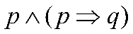and q are equivalent.
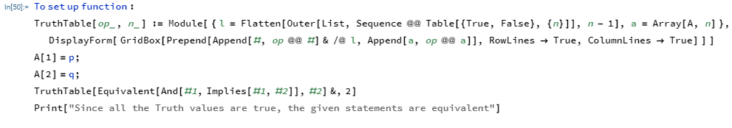
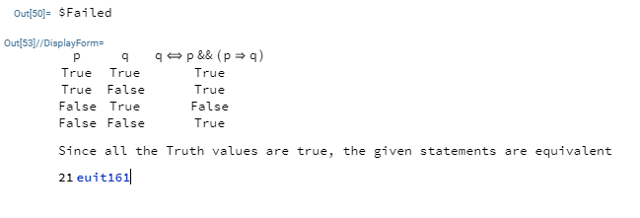

- Write a program to check whether the statements 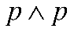and p are equivalent.

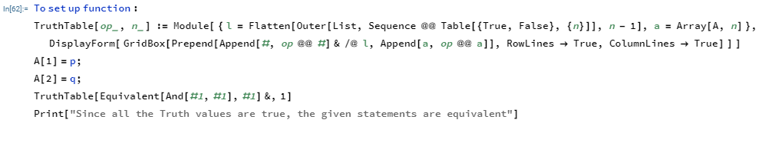
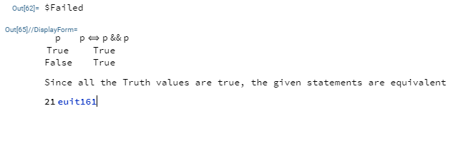

- Generate the truth table to portray the validity of Absorption Law.

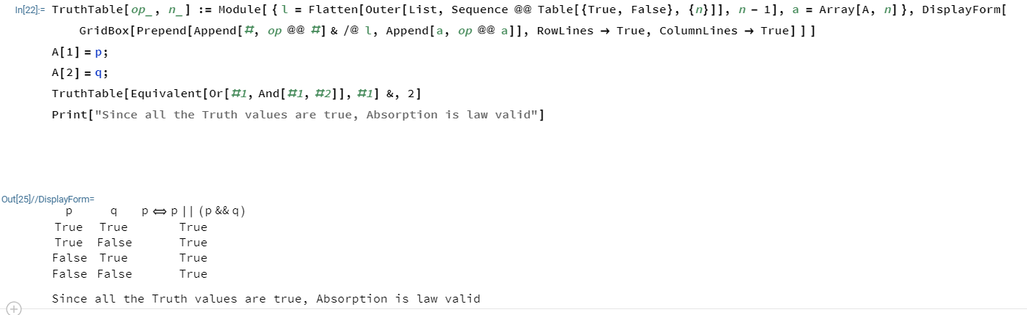

- Generate the truth table to portray the validity of Contra positive Law.

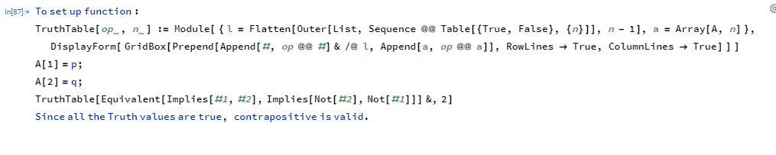
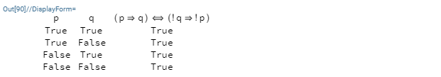

- Generate the truth table to portray the validity of Distributive Law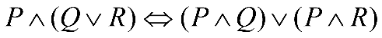.

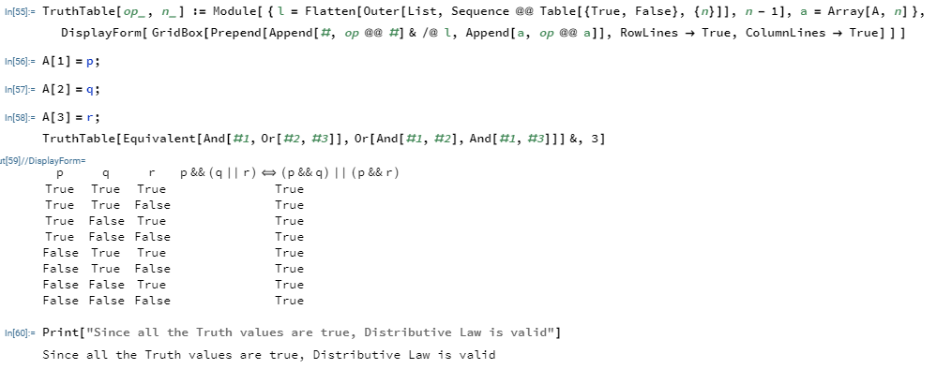

Conclusion :
Mathematica represents Boolean expressions in symbolic form, so they can not only be evaluated, but also be symbolically manipulated and transformed. Incorporating state-of-the-art quantifier elimination, satisfiability, and equational logic theorem proving, the Mathematica provides a powerful framework for investigations based on Boolean algebra.

EX.NO:3 | Examine the logical validity of arguments using suitable mathematical software
DATE:24.8.22

OBJECTIVE:
To make decisions on the validity of arguments by assigning the truth table for using mathematica.
SOFTWARE REQUIRED:
Execute Wolframcloud notebook (https://www.wolframcloud.com)
QUESTION 1:

Write a program to check the validity of modus phonens.
To set up function:
TruthTable[op_, n_] := Module[ { l = Flatten[Outer[List, Sequence @@ Table[{True, False}, {n}]], n - 1], a = Array[A, n] }, DisplayForm[ GridBox[Prepend[Append[#, op @@ #]& /@ l, Append[a, op @@ a]], RowLines -> True, ColumnLines -> True] ] ]
A[1]=p;
A[2]=q;
CODING
TruthTable[[#1 && (#1⇒ #2)]⇒#2 &, 2]
OUTPUT
p | q | (p&&p⇒q)⇒ q
True | True | (True⇒True)⇒True
True | False | (True⇒false)⇒False
False | True | False⇒True
False | False | False⇒False
QUESTION 2:

Generate the truth table to Check the validity of the arguments,”If he is hungry then he can eat. If he eats then he will be happy. He is hungry. Therefore he is happy.”
p: He is hungry, q: He can eat, r: He is happy.
The premises are p→q, q→r, p.
Conclusion : r
Truth table for [p∧(p→q)∧(q→r)⇒r
To set up function:
TruthTable[op_, n_] := Module[ { l = Flatten[Outer[List, Sequence @@ Table[{True, False}, {n}]], n - 1], a = Array[A, n] }, DisplayForm[ GridBox[Prepend[Append[#, op @@ #]& /@ l, Append[a, op @@ a]], RowLines -> True, ColumnLines -> True] ] ]
A[1]=p;
A[2]=q;
A[3]=r;

CODING

TruthTable[(#1&&(#1⇒#2)&&(#2⇒#3))⇒#3 &, 3]
OUTPUT
p | q | _{r} | p&&(p⇒q)&&(q⇒r)⇒r
True | True | True | True
True | True | False | True
True | False | True | True
True | False | False | True
False | True | True | True
False | True | False | True
False | False | True | True
False | False | False | True
Problems for Practice
- Write a program to check the validity of (←p ∧ (p ∨ q))⇒q.
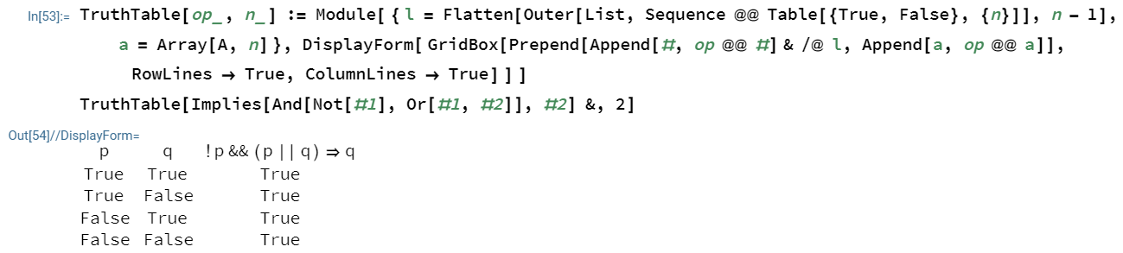
- Write a program to check the validity of Chain Rule.
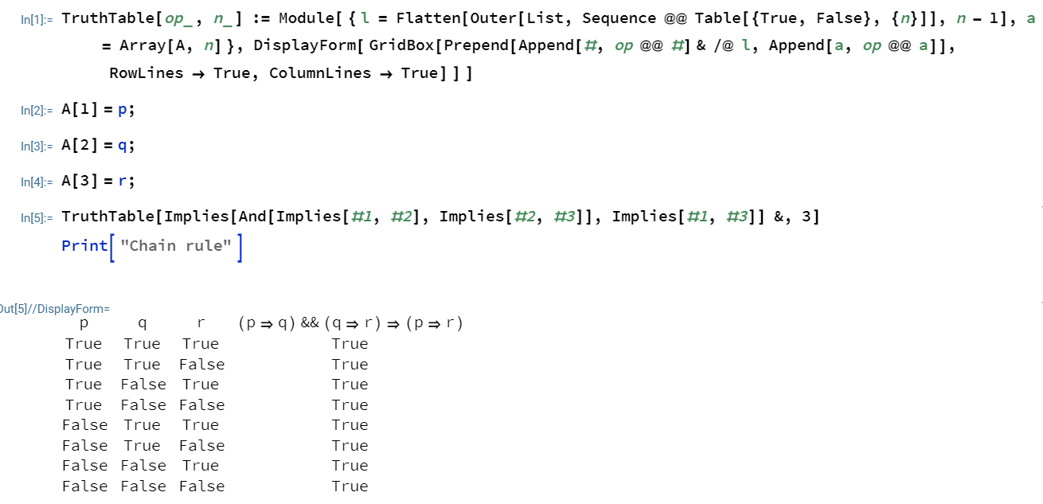

- Write a program to check the validity of Modus Tollens.

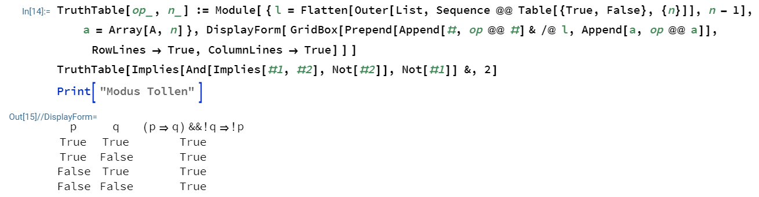

- Write a program to check the validity of (p∧←q) ⇔ ←(p→q).

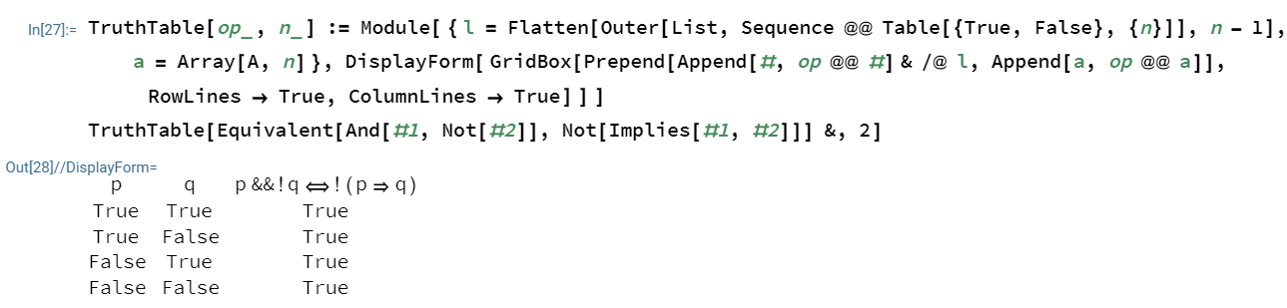

- Write a program to show that S∨R is tautologically implied by (P∨Q)∧(P→R)∨(Q→S).

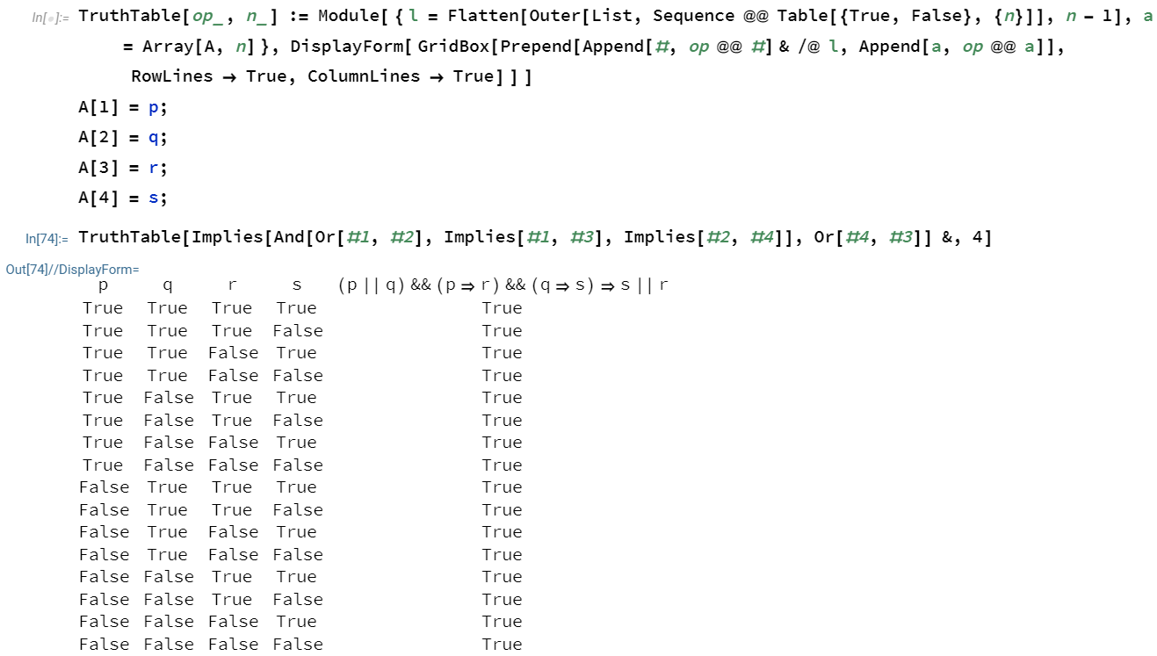

Conclusion :
Mathematica represents Boolean expressions in symbolic form, so they can not only be evaluated, but also be symbolically manipulated and transformed. Incorporating state-of-the-art quantifier elimination, satisfiability, and equational logic theorem proving, the Mathematica provides a powerful framework for investigations based on Boolean algebra

EX.NO:4 | Testing the truth values of the statements by logical operators using MATLAB
DATE:24.8.22

OBJECTIVE:
To test the truth values of the statements by logical operators using MATLAB
SOFTWARE REQUIRED:
Execute MATLAB/Octave Online (GNU Octave, v4.2.1)
QUESTION NO: 1
Check whether x is larger than 8.

Solution:
MATLAB Program
>> x = 5;
>> x > 8

OUTPUT
ans =
logical
0 (false)

QUESTION NO: 2
Check whether x is not equal to 3.

Solution:
MATLAB Program
>> x = 5;
>> x ∼= 3

OUTPUT
ans =
logical
- (true)

Problems for Practice
1.Check whether x lies between -3 and 4.
a)x= 0, b) x= 4, c) x= -2
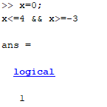
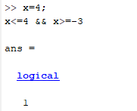
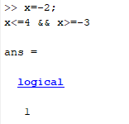
2.Check whether y elements [ 8 20 9 2 19 7 10] are larger than or equal to x elements x = [15 6 9 4 11 7 14]?

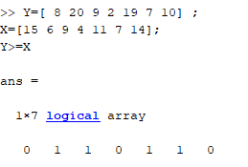

- Check whether a) x elements are equal to y elements.
- x elements are not equal to y elements.
Given x = [8 20 9 2 19 7 10]; y = [ 8 -20 8 2 17 7 12];

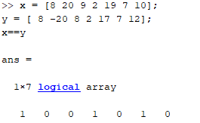

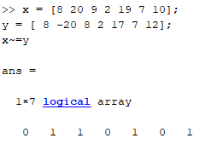
- Check the truth values for the given matrix 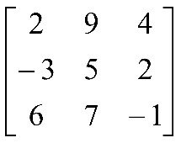 if a) x< = 2, b) x> -2

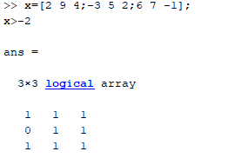

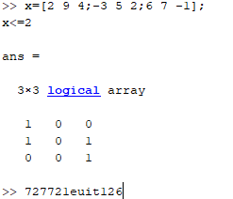
- Check the truth values of the following,” x is equal to 12 or x is less than 3” if a) x = 12, b) x = 11.

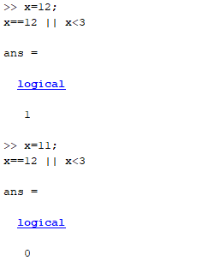

Conclusion :
MATLAB is an extraordinarily useful tool for all kinds of engineering analysis and design. Discrete mathematics in MATLAB are understandable computer programs and very easy to check the logical values.

EX.NO:5 | Verification of De-Morgan’s Law using MATLAB
DATE:26.8.22 | Verification of De-Morgan’s Law using MATLAB

OBJECTIVE:
To verify De-Morgan’s Law using MATLAB.
SOFTWARE REQUIRED:
Execute MATLAB/Octave Online (GNU Octave, v4.2.1)
QUESTION:
Verify De-Morgan’s Law for the sets u=[1 2 3 4 5 6 7 8], a=[2 3 4 5] and b=[6 3 7 8]
Solution :
De-Morgan’s Law:
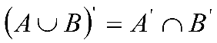 (FIRST LAW)
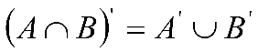 (SECOND LAW)
MATLAB Program
>>u = [1 2 3 4 5 6 7 8]
>>a = [2 3 4 5]
>>b = [6 3 7 8]
>>c=union(a,b)
>> d=setdiff(u,c) LHS OF FIRST LAW
>>e=setdiff(u,a)
>>f=setdiff(u,b)
>> g=intersect(e,f) RHS OF FIRST LAW
>>h=intersect(a,b)
>> i=setdiff(u,a) LHS OF SECOND LAW
>>j=union(e,f) RHS OF SECOND LAW

OUTPUT
u = 1 2 3 4 5 6 7 8
a = 2 3 4 5
b = 6 3 7 8
c = 2 3 4 5 6 7 8
d=1
e = 1 6 7 8
f = 1 2 4 5
g=1 // first law verified
h=3
i=1 2 4 5 6 7 8
j=1 2 4 5 6 7 8 //second law verified

Problems for Practice
- Verify De-Morgan’s Law for the sets u=[2 3 4 5 6 7 8 9 10], a=[7 8 9] and b=[6 7 8 10]

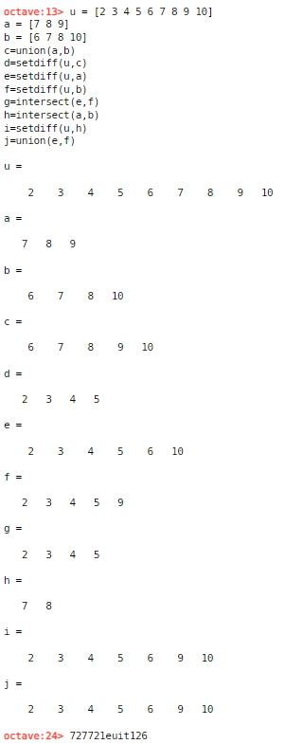

- Verify De-Morgan’s Law for the sets u=[11 12 13 14 15 16 17 18], a=[12 13 14 15] and b=[16 13 17 18]

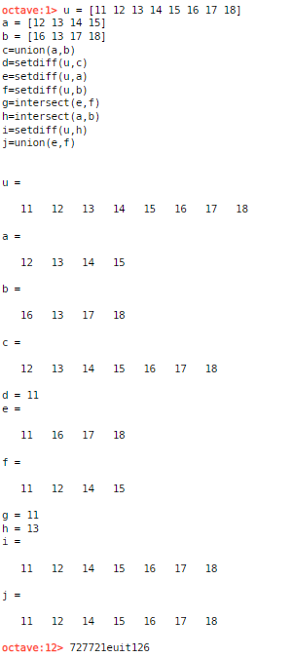

- Verify De-Morgan’s Law for the sets u=[1 2 3 4 5], a=[2 3 4 ] and b=[1 4 5]

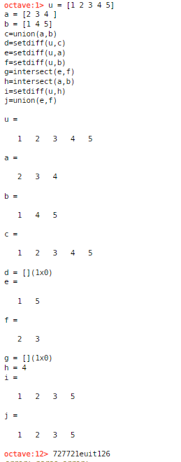

- Verify De-Morgan’s Law for the sets u=[2 3 4 5 6 7 8 9], a=[2 3 4 5] and b=[6 3 7 8]

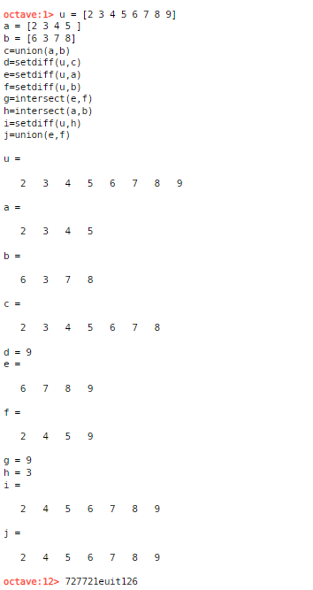

- Verify De-Morgan’s Law for the sets u=[1 2 3 4 5 6 7 8], a=[1 2 3] and b=[3 4 5]

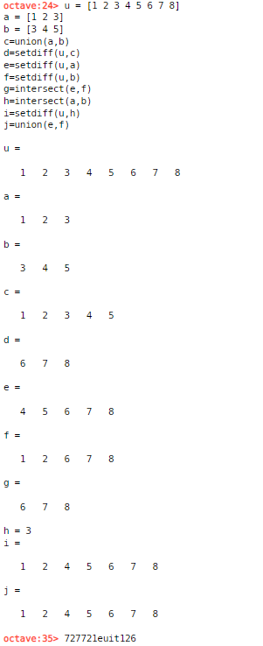

- Verify De-Morgan’s Law for the sets u=[9 10 11 12 13 14 15], a=[12 13 15] and b=[12 14 16]

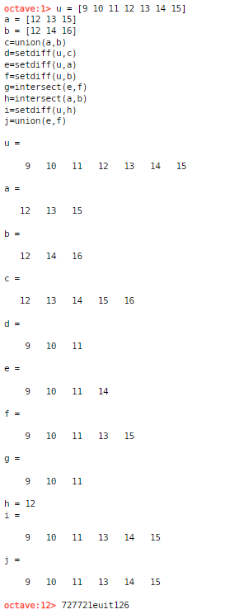

- Verify De-Morgan’s Law for the sets u=[1,2,3, 4, …, 20], a=[1,2,3,….15] and b=[10,11,12,…20]

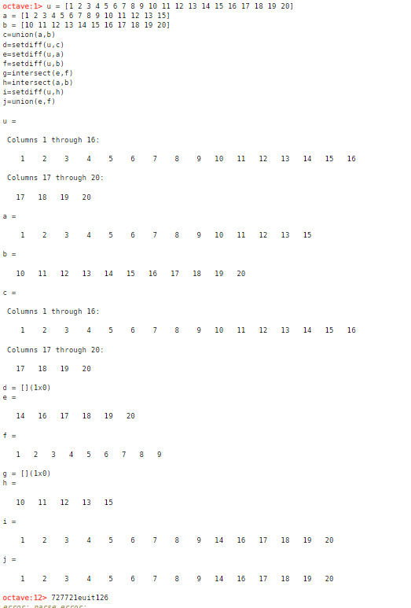

- Verify De-Morgan’s Law for the sets u=[1 2 5 6 7 8 9 10], a=[1 2 7 8] and b=[5 7 9 10]

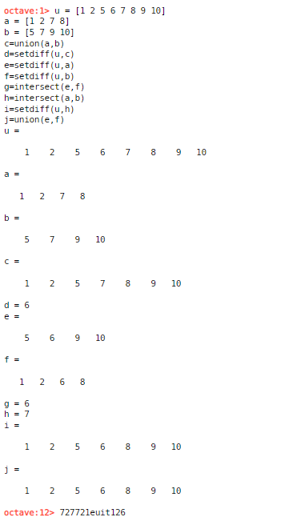

- Verify De-Morgan’s Law for the sets u=[1 2 3 4 5 6 7 8], a=[3 4 5] and b=[6 7 8]

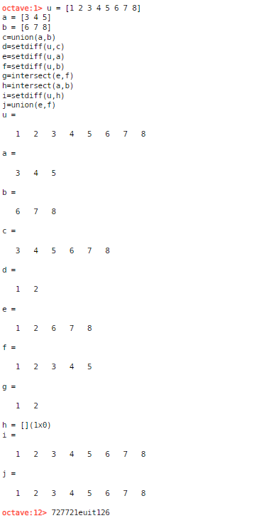

- Verify De-Morgan’s Law for the sets u=[1 2 5 7 8 9 10], a=[1 2 8] and b=[5 7 9]
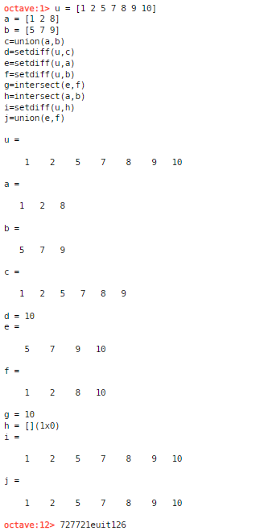

Conclusion :
MATLAB is an extraordinarily useful tool for all kinds of engineering analysis and design. Solving De-Morgan’s Law MATLAB are understandable computer programs and very easy to evaluate. MATLAB has several indexing styles that are not only powerful and flexible, but also readable and expressive.

EX.NO:6 | Set operations using MATLAB
DATE: 26.8.22 | Set operations using MATLAB

OBJECTIVE:
To execute set operations using MATLAB.
SOFTWARE REQUIRED:
Execute MATLAB/Octave Online (GNU Octave, v4.2.1)
QUESTION:
Find the union, intersection, difference, complement of the sets u=[1 2 3 4 5 6 7 8], a=[2 3 4 5] and b=[6 3 7 8]
MATLAB Program
>> u = [1 2 3 4 5 6 7 8 ]
>> a = [2 3 4 5]
>>b = [6 7 8 9]
>>c=union(a,b) //aUb
>>d=intersect(a,b) //a∩b
>>e=setdiff(a,b) //a-b
>>f=setdiff(b,a) //b-a
>>g=setdiff(u,a) //(complement of a)
>>h=setdiff(u,b) //(complement of b)
>>i=setxor(a,b) //aΔb (symmetric difference) (A-B)U(B-A)
OUTPUT
u =1 2 3 4 5 6 7 8
a = 2 3 4 5
b = 6 3 7 8
c=2 3 4 5 6 7 8
d=3
e = 2 4 5
f = 6 7 8
g = 1 6 7 8
h = 1 2 4 5
i= 2 4 5 6 7 8

Problems for Practice
- Find the union, intersection, difference, complement of the sets u=[2 3 4 5 6 7 8 9 10], a=[7 8 9] and b=[6 7 8 10]

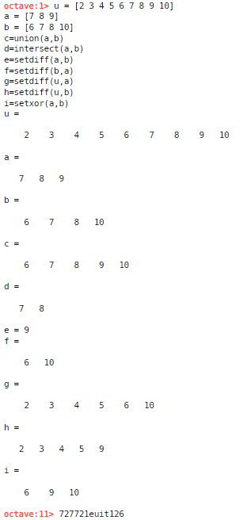

- Find the union, intersection, difference, complement of the sets u=[11 12 13 14 15 16 17 18], a=[12 13 14 15] and b=[16 13 17 18]

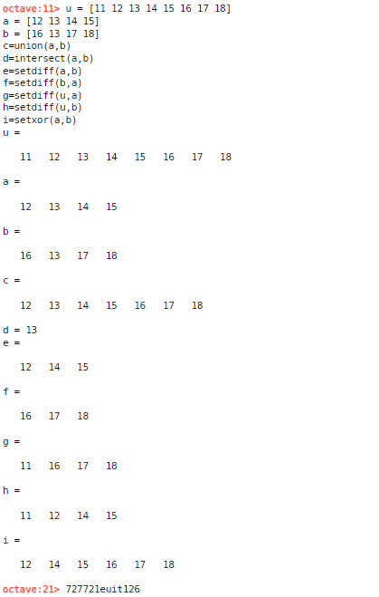

- Find the union, intersection, difference, complement of the sets u=[1 2 3 4 5], a=[2 3 4 ] and b=[1 4 5]

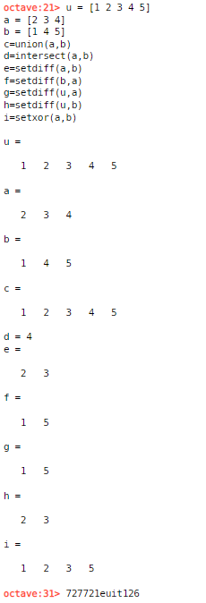

- Find the union, intersection, difference, complement of the sets u=[2 3 4 5 6 7 8 9], a=[2 3 4 5] and b=[6 3 7 8]

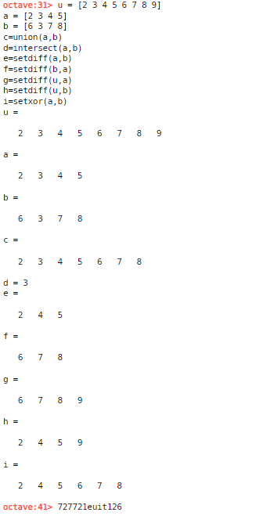

- Find the union, intersection, difference, complement of the sets u=[1 2 3 4 5 6 7 8], a=[1 2 3] and b=[3 4 5]

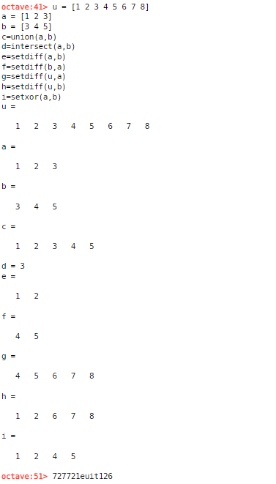

- Find the union, intersection, difference, complement of the sets u=[9 10 11 12 13 14 15], a=[12 13 15] and b=[12 14 16]

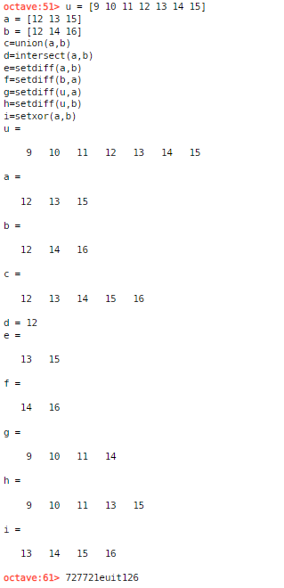

- Find the union, intersection, difference, complement of the sets u=[1,2,3, 4, …, 20], a=[1,2,3,….15] and b=[10,11,12,…20]

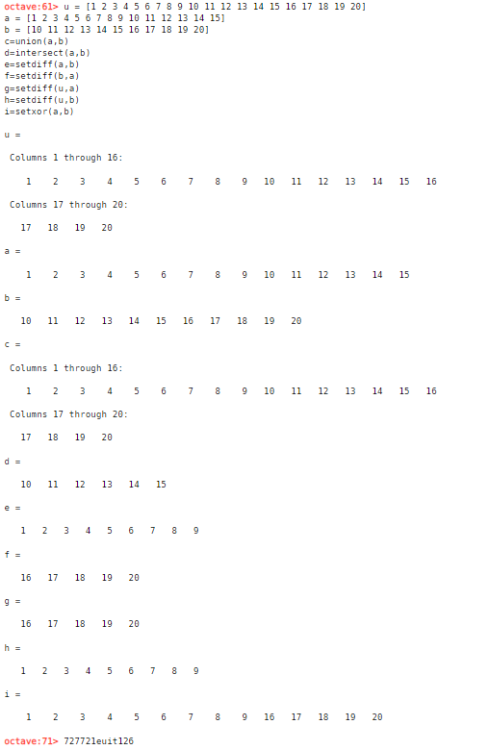

- Find the union, intersection, difference, complement of the sets u=[1 2 5 6 7 8 9 10], a=[1 2 7 8] and b=[5 7 9 10]

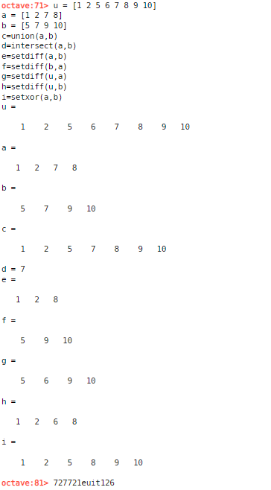

- Find the union, intersection, difference, complement of the sets u=[1 2 3 4 5 6 7 8], a=[3 4 5] and b=[6 7 8]

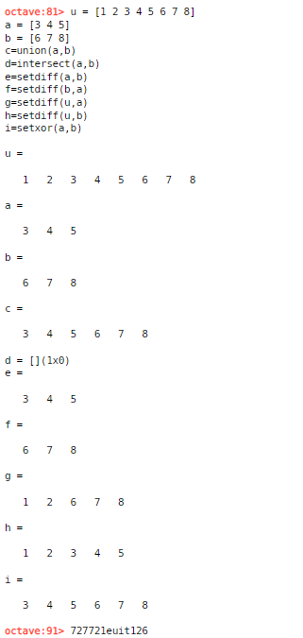

- Find the union, intersection, difference, complement of the sets u=[1 2 5 7 8 9 10], a=[1 2 8] and b=[5 7 9]

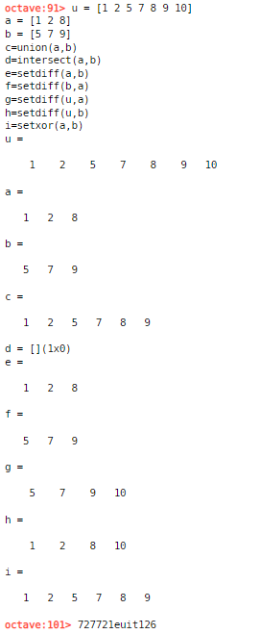

Conclusion :
MATLAB is an extraordinarily useful tool for all kinds of engineering analysis and design. Solving set theory related concepts in MATLAB are understandable computer programs and very easy to evaluate. MATLAB has several indexing styles that are not only powerful and flexible, but also readable and expressive.
EX.NO:7 | Compute permutations functions using suitable mathematical software
DATE: 26.8.22
OBJECTIVE:
To compute permutations functions using MATLAB.
SOFTWARE REQUIRED:
Execute MATLAB/Octave Online (GNU Octave, v4.2.1)
SYNTEX:
All possible permutations P= Perms(v)
P = perms(v) returns a matrix containing all permutations of the elements of vector v in reverse lexicographic order. Each row of P contains a different permutation of the n elements in v. Matrix P has the same data type as v, and it has n! rows and n columns.
QUESTION NO: 1
Find all permutations of {1,2,3}
Solution:
MATLAB Program
v=[1 2 3]
perms(v)
size(perms(v),1)

OUTPUT
v=[1 2 3]
v =
1 2 3
perms(v)
ans =

3 2 1
3 1 2
2 3 1
2 1 3
1 3 2
1 2 3
size(perms(v),1)
ans = 6

QUESTION NO: 2 Find P(6,3)
Solution:
MATLAB Program
P(n,r)=n!/(n-r)!

a=factorial(n)/factorial(n-r)

OUTPUT

a=factorial(6)/factorial(3)
a = 120

Problems for Practice
- Find all permutations of {112,2345,65743}
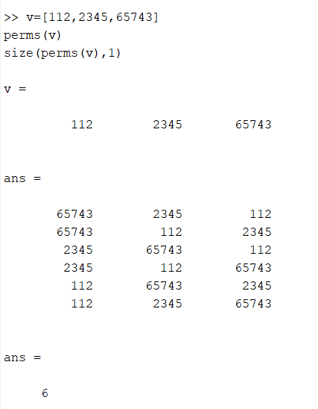
- Find all permutations of {1+1i 2+1i 3+1i}
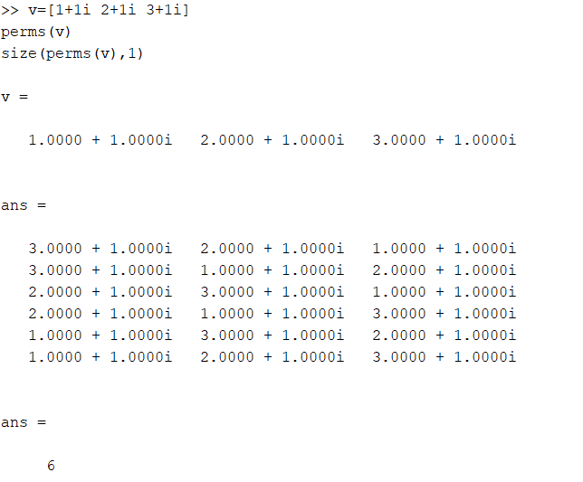
- Find all permutations of int16([1 2 3 4])

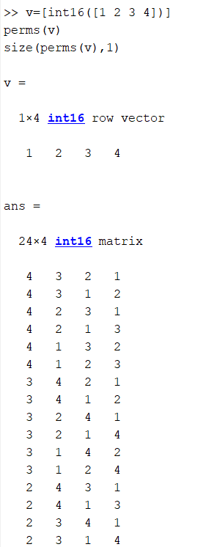

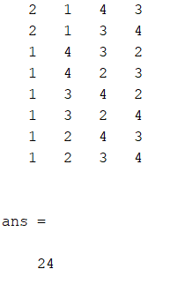

- Find all permutations of [ 'abcd' ]

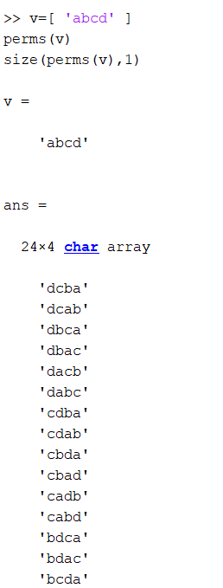
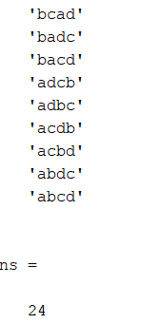

- Find P(8,1), P(12,3) & P(8,8)

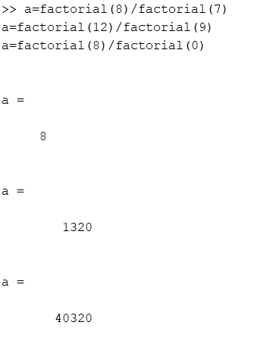

Conclusion :
MATLAB is an extraordinarily useful tool for all kinds of engineering analysis and design in MATLAB ideas in understandable computer programs and very easy to compute permutations functions.

EX.NO:8 | Compute combinations functions using suitable mathematical software
DATE:26.8.22
OBJECTIVE:
To compute combinations functions using MATLAB.
SOFTWARE REQUIRED:
Execute MATLAB/Octave Online (GNU Octave, v4.2.1)
SYNTEX:
All combinations C= nchoosek(n,k) C= nchoosek(v,k) returns a matrix containing all possible combinations of the elements of vector v taken k at a time. Matrix C has k columns and m!/((m–k)! k!) rows, where m is length(v)
QUESTION NO: 1

All Combinations of Five Numbers Taken Four at a Time {2,4,6,8,10}
Solution:
MATLAB Program
v=[2 4 6 8 10]
C = nchoosek(v,4)
size(C,1)

OUTPUT
v=[2 4 6 8 10]
v =

2 4 6 8 10
C = nchoosek(v,4)
C =

2 4 6 8
2 4 6 10
2 4 8 10
2 6 8 10
4 6 8 10
size(C,1)
ans = 5

QUESTION NO: 2 Find C(5,4)
Solution:
MATLAB Program
b = nchoosek(5,4)

OUTPUT
b = nchoosek(5,4)
b = 5

Problems for Practice
- Find all combinations of uint16([10 20 30])
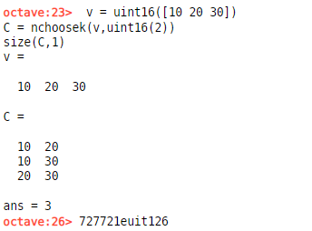
- Find all combinations of {1+1i 2+1i 3+1i}
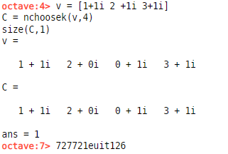
- Find all combinations of int16([1 2 3 4])
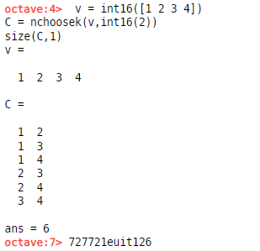
- Find all combinations of [ 'abcd' ]

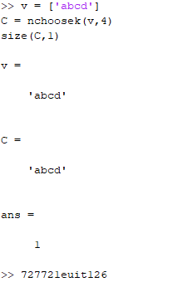

- Find C(8,1), C(5,3) & C(8,0)

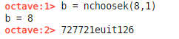

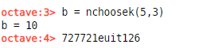

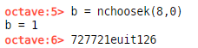

Conclusion :
MATLAB is an extraordinarily useful tool for all kinds of engineering analysis and design in MATLAB ideas in understandable computer programs and very easy to compute combination functions.
EX.NO:9 | Compute Prime numbers using MATLAB .
DATE:5.9.22 | Compute Prime numbers using MATLAB .

OBJECTIVE:
To Compute Prime numbers using MATLAB with examples.
SOFTWARE REQUIRED:
Execute MATLAB/Octave Online (GNU Octave, v4.2.1)

QUESTION NO: 1
Find prime numbers from 1 to 100.
MATLAB Program
INPUT
>>num = 1:100 ;
>>idx = isprime(num) ;
>>num(idx)
OUPUT:
2 3 5 7 11 13 17 19 23 29 31 37 41 43 47 53 59 61 67 71 73 79 83 89 97

Problems for Practice
SOLVE THE FOLLOWING:

- Find prime numbers from 100 to 200.

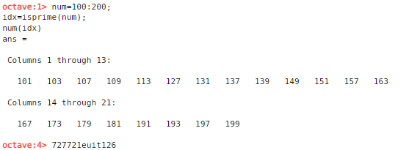

- Find prime numbers from 500 to 800.

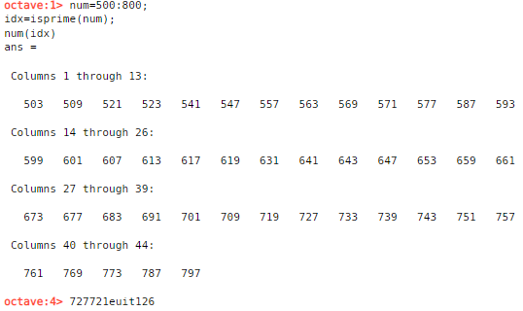

- Find prime numbers from 1000 to 2000.

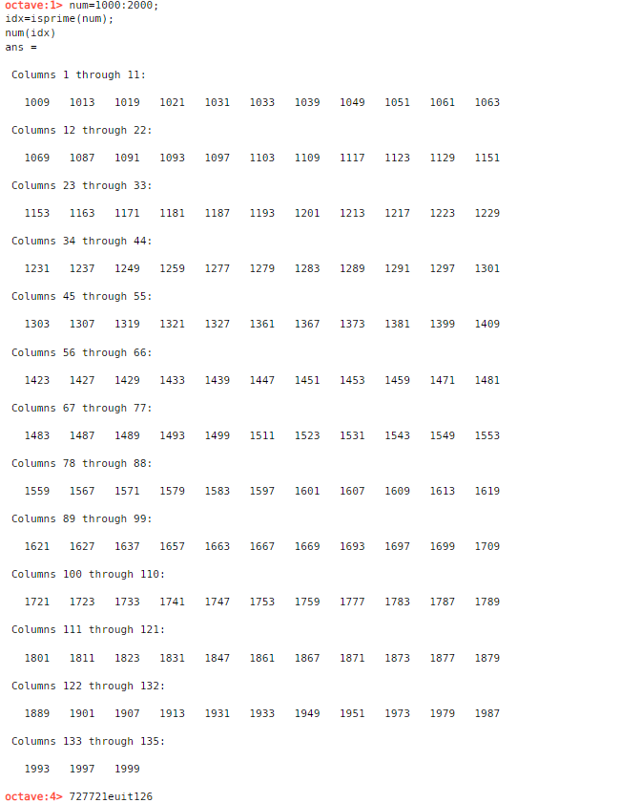

- Find prime numbers from 2500 to 3500.

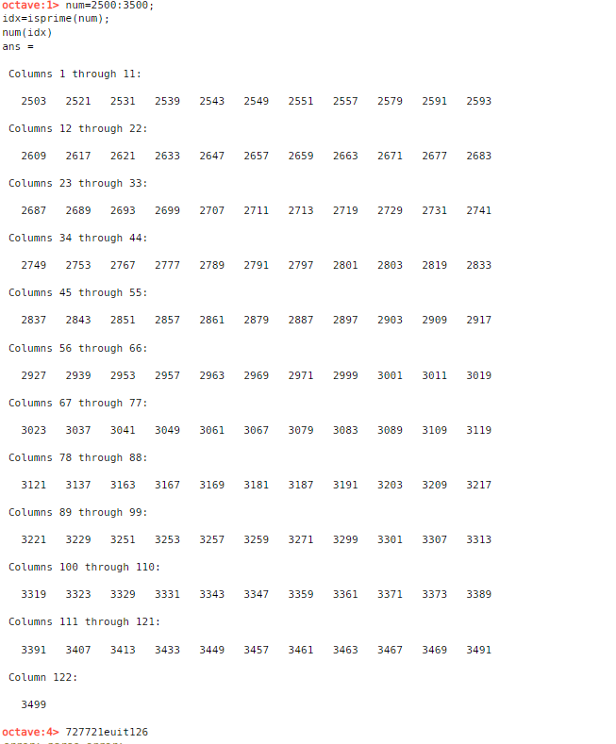

- Find prime numbers from 9000 to 10000.
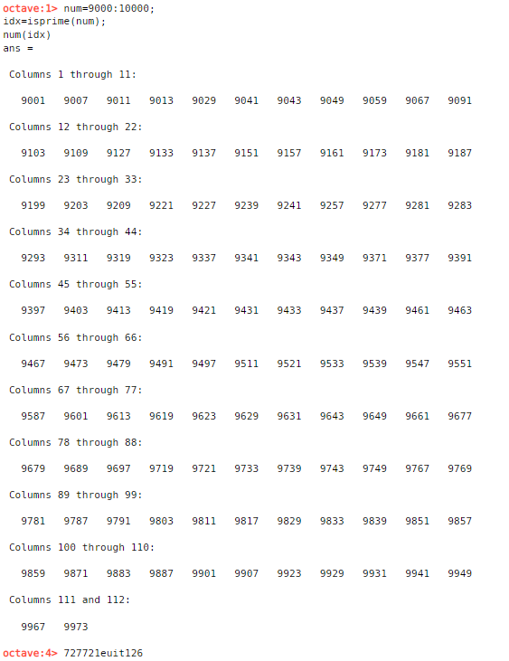

Conclusion :
We can say that this software and methodology offers strong possibilities, utilization is pretty easy for simple and advanced problems on finding prime numbers.

EX.NO:10 | Compute least common multiple of two integers using suitable mathematical software
DATE:5.9.22

OBJECTIVE:
To find least common multiple of integers using MATLAB.
SOFTWARE REQUIRED:
Execute MATLAB/Octave Online (GNU Octave, v4.2.1)
SYNTEX:
L = lcm(A,B)

L = lcm(A,B) returns the least common multiple of corresponding elements of arrays A and B. Inputs A and B must contain positive integer elements and must be the same size (or either can be scalar).
QUESTION NO: 1
Find the least common multiple of 8 and 40.

Solution:
MATLAB Program
L = lcm(8,40)

OUTPUT
L = 40
QUESTION NO: 2
Find LCM of 3/4, 7/3, 11/2, 12/3, 33/4

Solution:

MATLAB Program
lcm (sym([3/4, 7/3, 11/2, 12/3, 33/4]))

OUTPUT
924

Problems for Practice

- Find the lowest number which is exactly divisible by 18 and 24.
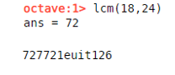

- Find the lowest common multiple of 24, 48 .

- Find the LCM of the following numbers:
(a)4,7,12,84
(b)25,15,36
(c)24,36,40
(d)27,36
(e) 4,8,18
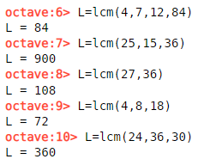

- Find the LCM of 0.6, 9.6 and 0.36.

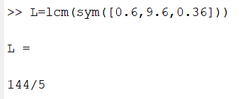


- Find the L.C.M. of 0.48, 0.72 and 0.108.
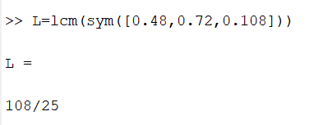

- Find LCM of 5/8,16/15,2/3
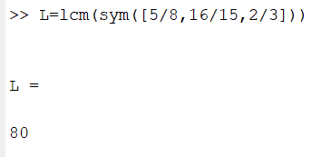

Conclusion:
MATLAB is an extraordinarily useful tool for all kinds of engineering analysis and design in MATLAB ideas in understandable computer programs and very easy to compute least common multiple.
EX.NO:11 | Compute greatest common divisor of two integers using suitable mathematical software
DATE:5.9.22

OBJECTIVE:
To find greatest common divisor of two integers using MATLAB.
SOFTWARE REQUIRED:
Execute MATLAB/Octave Online (GNU Octave, v4.2.1)
SYNTEX:
G = gcd(A,B)

G = gcd(A,B) returns the greatest common divisor of corresponding elements of arrays A and B. Inputs A and B must contain positive integer elements and must be the same size (or either can be scalar).
QUESTION NO: 1
Find the greatest common divisor of 60 and 90.

Solution:
MATLAB Program
G = gcd(60,90)

OUTPUT
G = 30

QUESTION NO: 2
Find GCD of 18, 72, 132, 96, 198

Solution:

MATLAB Program
G= gcd (18, 72, 132, 96, 198)

OUTPUT
6

Problems for Practice

1.Find the greatest common divisor of 625 and 1000.

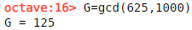

- Find the greatest common divisor of 12345 and 54321 .

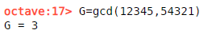

- Find the gcd (1819, 3587).
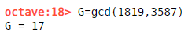

- Find the gcd (512, 320)
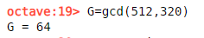

- Find the gcd (396,504,636).
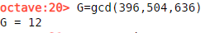

- Find the gcd (84, 90,120).
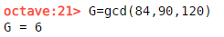

- Find the GCD of 0.6, 9.6 and 0.36.

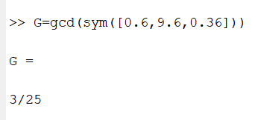

- Find the GCD of 0.48, 0.72 and 0.108.
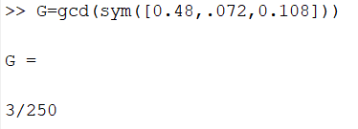

- Find GCD of 5/8,16/15 ,2/3.

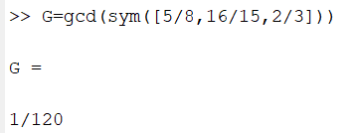

- Find GCD of 3/4, 7/3, 11/2, 12/3, 33/4
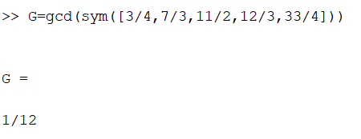

Conclusion:
MATLAB is an extraordinarily useful tool for all kinds of engineering analysis and design in MATLAB ideas in understandable computer programs and very easy to compute greatest common divisor.
EX.NO:12 | Compute Quotient and remainder of two integers by division algorithm using suitable mathematical software
DATE:5.9.22

OBJECTIVE:
To find Quotient and remainder of two integers using MATLAB.
SOFTWARE REQUIRED:
Execute MATLAB/Octave Online (GNU Octave, v4.2.1)
SYNTEX:
[Q , R] = quorem(A , B , var)
[Q , R] = quorem(A , B )

Description

[Q,R] = quorem(A,B,var) divides A by B and returns the quotient Q and remainder R of the division, such that A = Q*B + R. This syntax regards A and B as polynomials in the variable var.

If A and B are matrices, quorem performs elements-wise division, using var as a variable. It returns the quotient Q and remainder R of the division, such that A = Q.*B + R.

Input Arguments

A — Dividend (numerator)
symbolic integer | polynomial | symbolic vector | symbolic matrix

B — Divisor (denominator)
symbolic integer | polynomial | symbolic vector | symbolic matrix

var — Polynomial variable
symbolic variable

QUESTION NO: 1
Compute the quotient and remainder of the division of these multivariate polynomials x3y4-2xy+5x+1 and xy

Solution:
MATLAB Program
syms x y
p1 = x^3*y^4 - 2*x*y + 5*x + 1;
p2 = x*y;
[q, r] = quorem(p1, p2, y)

OUTPUT
q =
x^2*y^3 - 2

r =
5*x + 1

QUESTION NO: 2
Compute the quotient and remainder of the division of these univariate polynomials:
x5 and x3-2x+5
Solution:
MATLAB Program
syms x
p = x^3 - 2*x + 5;

[q, r] = quorem(x^5, p)

OUTPUT
q =
x^2 + 2

r =
- 5*x^2 + 4*x – 10

QUESTION NO: 3
Compute the quotient and remainder of the division of these integers
100000=985q+r

Solution:
MATLAB Program
[q, r] = quorem(sym(100000), sym(985))

OUTPUT
q =
101

r =
515

Problems for Practice
- Compute the quotient and remainder of the division of these multivariate polynomials x4y4-4xy+6x+2 and x2y2

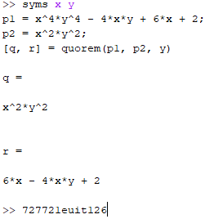
- Compute the quotient and remainder of the division of these multivariate polynomials x5y4+4xy+8x+1 and x3y

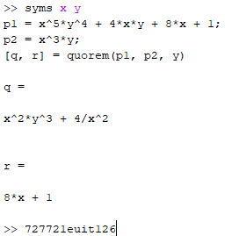

- Compute the quotient and remainder of the division of these univariate polynomials:x4 and 2x2+3x+7

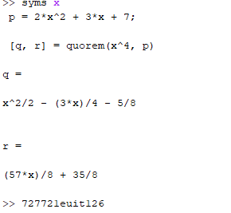
- Compute the quotient and remainder of the division of these univariate polynomials:x5 and x3-4x+8
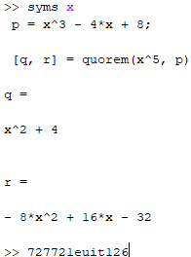

- Compute the quotient and remainder of the division of these integers
54321=12345q+r
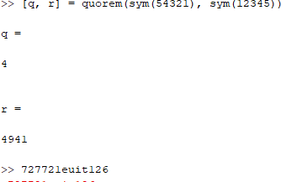

6.Compute the quotient and remainder of the division of these integers
3587=1819q+r
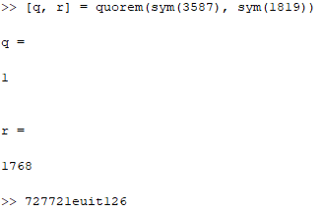
- Compute the quotient and remainder of the division of these integers
337500=21600q+r
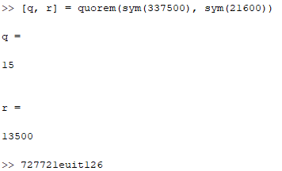
- Compute the quotient and remainder of the division of these integers
7469=2464q+r
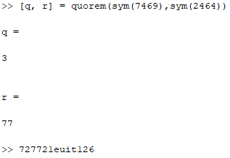

- Compute the quotient and remainder of the division of these integers
9888=6060q+r
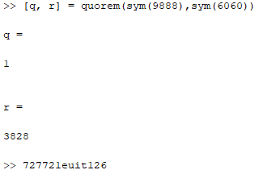

- Compute the quotient and remainder of the division of these integers
14038=1529q+r
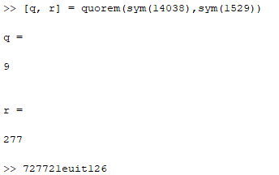

Conclusion:
MATLAB is an extraordinarily useful tool for all kinds of engineering analysis and design in MATLAB ideas in understandable computer programs and very easy to compute quotient and remainder.

